**Week-3 Hands on Mandatory Exercises Spring Core and maven**

Exercise 1: Configuring a Basic Spring Application

Code:

In this the pom.xml File Code is:

<project xmlns="http://maven.apache.org/POM/4.0.0"

xmlns:xsi="http://www.w3.org/2001/XMLSchema-instance"

xsi:schemaLocation="http://maven.apache.org/POM/4.0.0

http://maven.apache.org/xsd/maven-4.0.0.xsd">

<modelVersion>4.0.0</modelVersion>

<groupId>com.library</groupId>

<artifactId>LibraryManagement</artifactId>

<version>1.0-SNAPSHOT</version>

<repositories>

<repository>

<id>central</id>

<name>Maven Central</name>

<url>https://repo.maven.apache.org/maven2</url>

</repository>

</repositories>

<dependencies>

<dependency>

<groupId>org.springframework</groupId>

<artifactId>spring-context</artifactId>

<version>5.2.5.RELEASE</version>

</dependency>

</dependencies>

<build>

<plugins>

<plugin>

<groupId>org.apache.maven.plugins</groupId>

<artifactId>maven-compiler-plugin</artifactId>

<version>6.1.15</version>

<configuration>

<source>1.8</source>

<target>1.8</target>

</configuration>

</plugin>

</plugins>

</build>

</project>

In src/main/java/com/library/repository/BookRepository.java

Code:

package com.library.repository;

public class BookRepository {

public void saveBook() {

System.out.println("Book saved to the repository!");

}

}

In src/main/java/com/library/service/BookService.java

Code:

package com.library.service;

import com.library.repository.BookRepository

public class BookService {

private BookRepository bookRepository;

public void setBookRepository(BookRepository bookRepository) {

this.bookRepository = bookRepository;

}

public void addBook() {

System.out.println("BookService: Adding a book...");

bookRepository.saveBook();

}

}

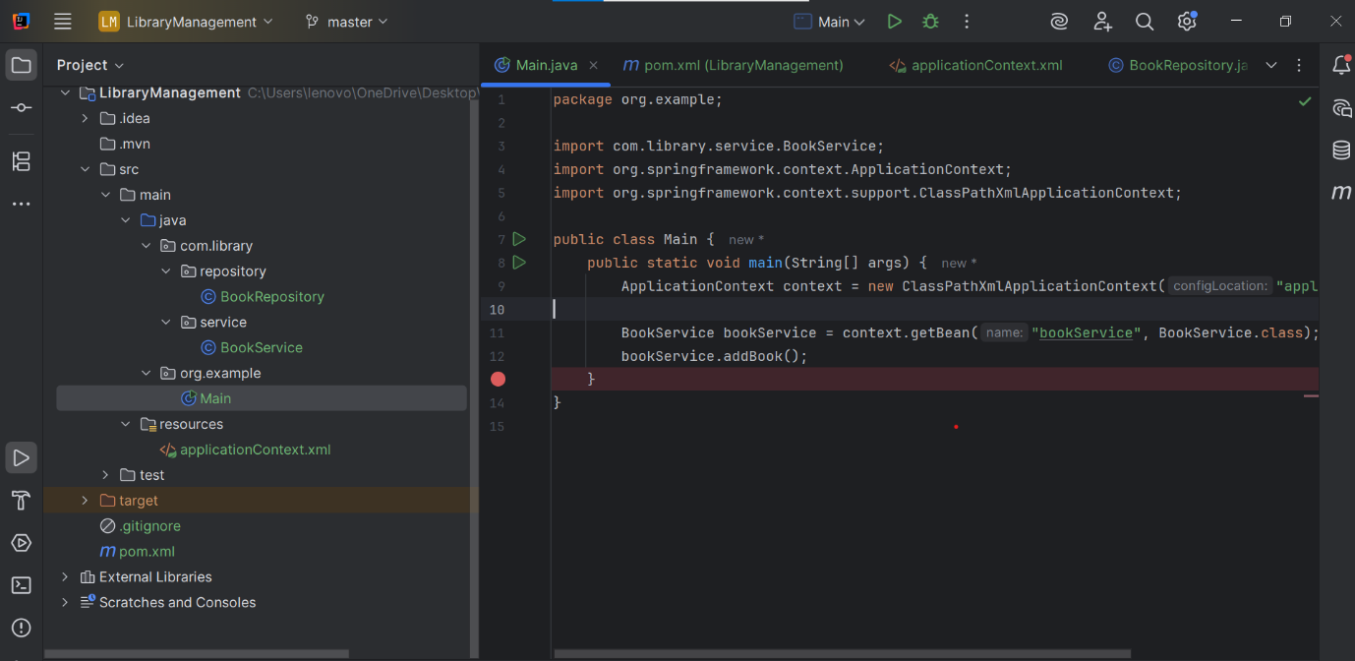

Output:

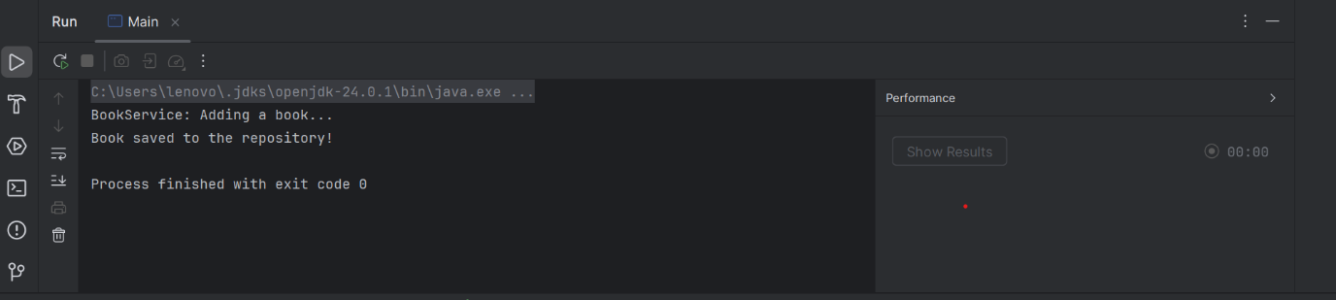

Exercise 2: Implementing Dependency Injection

In a src/main/resources/applicationContext.xml:

Code:

<?xml version="1.0" encoding="UTF-8"?>

<beans xmlns="http://www.springframework.org/schema/beans"

xmlns:xsi="http://www.w3.org/2001/XMLSchema-instance"

xsi:schemaLocation="

http://www.springframework.org/schema/beans

http://www.springframework.org/schema/beans/spring-beans.xsd">

<!-- Bean definition for BookRepository -->

<bean id="bookRepository" class="com.library.repository.BookRepository"/>

<!-- BookService with dependency injection -->

<bean id="bookService" class="com.library.service.BookService">

<property name="bookRepository" ref="bookRepository"/>

</bean>

</beans>

In a src/main/java/com/library/service/BookService.java

Code:

package com.library.service;

import com.library.repository.BookRepository;

public class BookService {

private BookRepository bookRepository;

// Setter for dependency injection

public void setBookRepository(BookRepository bookRepository) {

this.bookRepository = bookRepository;

}

public void addBook() {

System.out.println("BookService: Adding a book...");

bookRepository.saveBook();

}

}

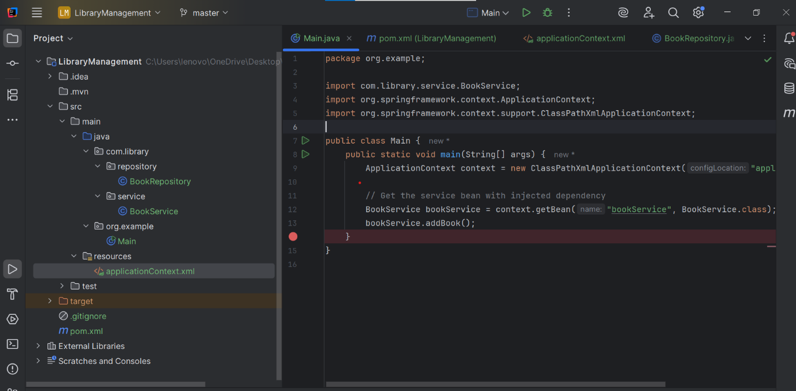Output:

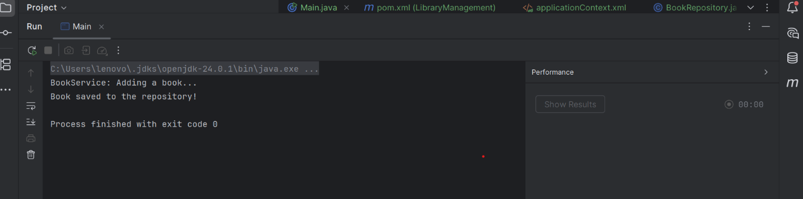

Exercise 4: Creating and Configuring a Maven Project

In pom.xml:

Code:

<project xmlns="http://maven.apache.org/POM/4.0.0"

xmlns:xsi="http://www.w3.org/2001/XMLSchema-instance"

xsi:schemaLocation="http://maven.apache.org/POM/4.0.0

http://maven.apache.org/xsd/maven-4.0.0.xsd">

<modelVersion>4.0.0</modelVersion>

<groupId>com.library</groupId>

<artifactId>LibraryManagement</artifactId>

<version>1.0-SNAPSHOT</version>

<!-- Repositories (optional if using Maven Central) -->

<repositories>

<repository>

<id>central</id>

<name>Maven Central</name>

<url>https://repo.maven.apache.org/maven2</url>

</repository>

</repositories>

<dependencies>

<!-- Spring Core Container -->

<dependency>

<groupId>org.springframework</groupId>

<artifactId>spring-context</artifactId>

<version>5.2.5.RELEASE</version>

</dependency>

<!-- Spring AOP -->

<dependency>

<groupId>org.springframework</groupId>

<artifactId>spring-aop</artifactId>

<version>5.2.5.RELEASE</version>

</dependency>

<!-- Spring Web MVC -->

<dependency>

<groupId>org.springframework</groupId>

<artifactId>spring-webmvc</artifactId>

<version>5.2.5.RELEASE</version>

</dependency>

<!-- Servlet API (required by Spring MVC) -->

<dependency>

<groupId>javax.servlet</groupId>

<artifactId>javax.servlet-api</artifactId>

<version>4.0.1</version>

<scope>provided</scope>

</dependency>

</dependencies>

<!-- Step 3: Compiler Plugin -->

<build>

<plugins>

<plugin>

<groupId>org.apache.maven.plugins</groupId>

<artifactId>maven-compiler-plugin</artifactId>

<version>3.8.1</version>

<configuration>

<source>1.8</source>

<target>1.8</target>

</configuration>

</plugin>

</plugins>

</build>

</project>

In main:

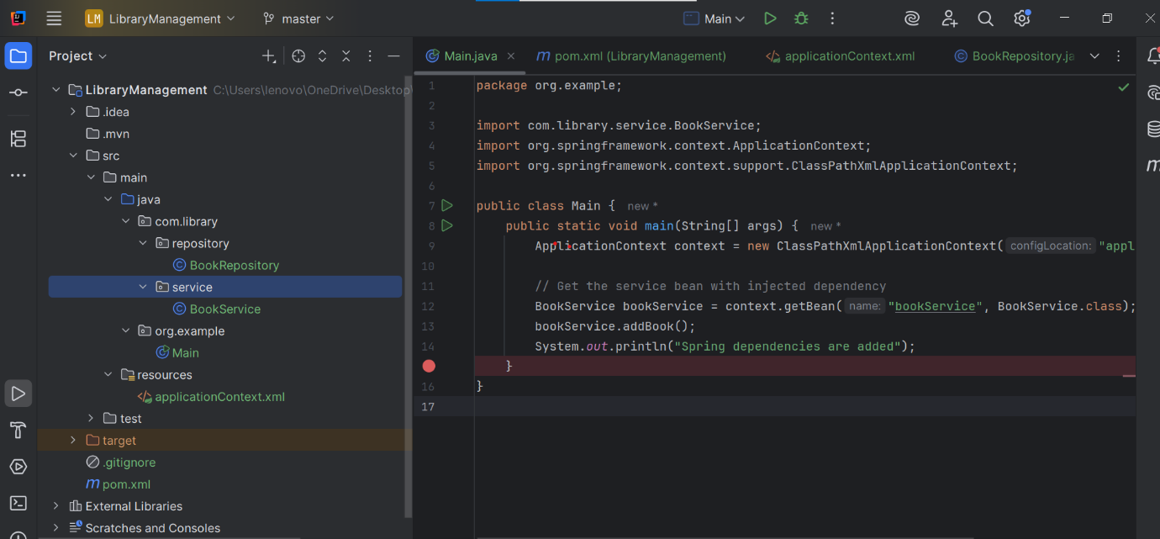**Output:**

